# Concept of Network :

➔ "A computer network is a group of computers and devices interconnected to each other allowing the computers to communicate with each other and share resources and information".

# OR

➔ Computer network is a collection of computers and devices (printer, scanner) connected together via communication devices (nic,hub,router,etc..) and transmission media .(broadcast network , point- to-point network) in order to share resources (such as printers and CDs), exchange files, or allow electronic communications.

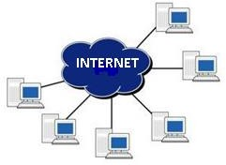

# What is Network ?

➔ "The term "network" refers to a group of entities (objects, entity, people, etc.) which are connected to one another. A network, therefore, allows material or immaterial elements to be circulated among all of these entities, based on well- defined rules"

➔ **Network:** A group of computers and peripheral devices connected to each other. Note that the smallest possible network is two computers connected together.

➔ **Networking:** Implementing tools and tasks for linking computers so that they can share resources over the network.

# Depending on what kind of entity is involved, the term used will differ:

➔ **Transportation network:** A combination of infrastructure and vehicles used for transporting people and goods between different geographic areas.

➔ **Telephone network:** Infrastructure for transporting voice signals from one telephone station to another.

➔ **Neural network :** A group of brain cells connected to each other

➔ **Computer network:** A group of computers linked to each other with physical lines, exchanging information as digital data.

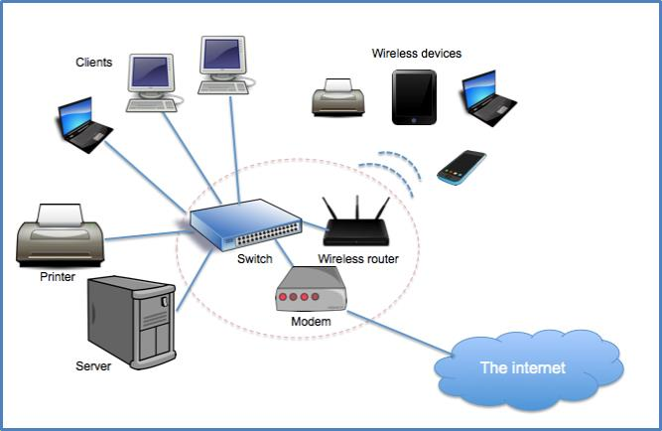

# Why network is required?

* 1. To share computer file.
  2. To share computer equipment
  3. To improve communication speed and accuracy
  4. Low cost of transfer of data

# Why you need a computer network?

**File sharing:** Have you ever needed to access a file stored on another computer? A network makes it easy for everyone to access the same file and prevents people from accidentally creating different versions.

**Printer sharing:** If you use a computer, chances are you also use a printer. With a network, several computers can share the same printer.

**Communication and collaboration:** It's hard for people to work together if no one knows what anyone else is doing. A network allows employees to share files view other people's work, and exchange ideas more efficiently.

In a larger office, you can use e-mail and instant messaging tools to communicate quickly and store messages for future

**Organization:** A variety of scheduling software is available that makes it possible to arrange meetings without constantly checking everyone's schedules.

**Remote access:** Having your own network allows greater mobility while maintaining the same level of productivity. With remote access in place, users are able to access the same files, data, and messages even when they're not in the office. This access can even be given to mobile handheld devices.

**Data protection:** You should know by now that it's vital to back up your computer data regularly.

# Advantage Of Network :

➔ people can communicate each other

➔ peripherals can be shared E.G. printer

➔ log ins can be shared through the network for people to log on their own computer

➔ data sharing, resources, sharing, reliability , easier backups and many more

# Dis-advantage Of Network :

➔ people can access the network and steal data

➔ if the network gets a virus then personal data is made vulnerable

➔ The main disadvantage would be security concerns, i.e. someone hacking into your network.

# Components Of Network :

➔ Computer networks components comprise both physical parts as well as the software required for installing computer networks, both at organizations and at home.

➔ The hardware components are the server, client, peer, transmission medium, and connecting devices. The software components are operating system and protocols.

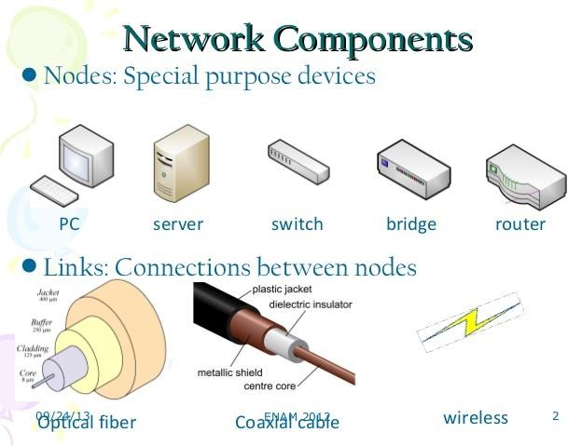➔

# Hardware Components

1. **Server:** A server is a computer in network that provides services to the client computers such as logon requests processing, files access and storage, internet access, printing access and many other types of services. Servers are mostly equipped with extra hardware such as plenty of external memory (RAM), more data store capacity (hard disks), high processing speed and other features.

**Network Server** is a computer in Network that is designated to provide one or more network service. For example file server, database server etc.

A network server designated to provide one particular service is known as **dedicated server.**For example if a computer is assigned for database service only then that computer is known as dedicated database server.

1. **Client:** The client is a process that sends a message to a server process requesting that the server perform a task.

Client programs usually manage the user-interface portion of the application, validate data entered by the user, dispatch requests to server programs, and sometimes execute business logic. The client-based process is the front- end of the application that the user sees and interacts with. The client process contains solution-specific logic and provides the interface between the user and the rest of the application system.

The **client process** also manages the local resources that the user interacts with such as the monitor, keyboard workstation CPU and peripherals. One of the key elements of client workstation is the graphical user interface (GUI).

A **server process** (program) fulfils the client request by performing the task requested. Server programs generally receive requests from client programs, execute database retrieval and updates, manage data integrity and dispatch responses to client requests.

1. **Peers:** Peers are computers that provide as well as receive services from other peers in a workgroup network.
2. **Transmission Media:** Transmission media are the channels through which data is transferred from one device to another in a network. Transmission media may be guided media like coaxial cable, fibre optic cables etc; or maybe unguided media like microwaves, infra-red waves etc.
3. **Connecting Devices:** Connecting devices act as middleware between networks or computers, by binding the network media together. Some of the common connecting devices are:

Routers, Bridges, Hubs .Repeaters, Switches, etc.

# Software Components

1. **Networking Operating System:** Network Operating Systems is typically installed in the server and facilitate workstations in a network to share files, database, applications, printers etc.
2. **Protocol Suite:** A protocol is a rule or guideline followed by each computer for data communication. Protocol suite is a set of related protocols that are laid down for computer networks. The two popular protocol suites are:
   1. OSI Model (Open System Interconnections)
   2. TCP / IP Model

## **Characteristics of a Computer Network**

* Share resources from one computer to another.
* Create files and store them in one computer, access those files from the other computer(s) connected over the network.
* Connect a printer, scanner, or a fax machine to one computer within the network and let other computers of the network use the machines available over the network.

# Why we need computer networks? Need for Computer Networking

Computer networks help users on the network to share the resources and in communication. Can you imagine a world now without emails, online newspapers, blogs, chat and the other services offered by the internet?

The following are the important uses and benefits of a computer network.

**File sharing:** Networking of computers helps the network users to share data files.

**Hardware sharing:** Users can share devices such as printers, scanners, CD-ROM drives, hard drives etc. Without computer networks, device sharing is not possible.

**Application sharing:** Applications can be shared over the network, and this allows to implement client/server applications

**User communication:** Networks allow users to communicate using e-mail, newsgroups, and video conferencing etc.

**Network gaming:** A lot of network games are available, which allow multi-users to play from different locations.

**Voice over IP (VoIP)**: Voice over Internet Protocol (IP) is a revolutionary change in telecommunication which allows to send telephone calls (voice data) using standard Internet Protocol (IP) rather than by traditional PSTN.

**Advantages and Disadvantages of Computer Network**

Computer networking has become one of the most successful ways of sharing information, where all computers are wirelessly linked together by a common network. Now, businesses and organizations heavily rely on it to get messages and information across to essential channels. Not only has that it benefited establishments, but also individuals, as they also need to share important information every day. But no matter how useful computer networking is, it does not come without drawbacks. Here are its advantages and disadvantages:

### List of Advantages of Computer Networking

**1. It enhances communication and availability of information.**  
Networking, especially with full access to the web, allows ways of communication that would simply be impossible before it was developed. Instant messaging can now allow users to talk in real time and send files to other people wherever they are in the world, which is a huge boon for businesses. Also, it allows access to a vast amount of useful information, including traditional reference materials and timely facts, such as news and current events.

**2. It allows for more convenient resource sharing.**  
This benefit is very important, particularly for larger companies that really need to produce huge numbers of resources to be shared to all the people. Since the technology involves computer-based work, it is assured that the resources they wanted to get across would be completely shared by connecting to a computer network which their audience is also using.

**3. It makes file sharing easier.**

Computer networking allows easier accessibility for people to share their files, which greatly helps them with saving more time and effort, since they could do file sharing more accordingly and effectively.

**4. It is highly flexible.**

This technology is known to be very flexible, as it gives users the opportunity to explore everything about essential things, such as software without affecting their functionality. Plus, people will have the accessibility to all information they need to get and share.

**5. It is an inexpensive system.**

Installing networking software on your device would not cost too much, as you are assured that it lasts and can effectively share information to your peers. Also, there is no need to change the software regularly, as mostly it is not required to do so.

**6. It increases cost efficiency.**

With computer networking, you can use a lot of software products available on the market which can just be stored or installed in your system or server, and can then be used by various workstations.

**7. It boosts storage capacity.**

Since you are going to share information, files and resources to other people, you have to ensure all data and content are properly stored in the system. With this networking technology, you can do all of this without any hassle, while having all the space you need for storage.

### List of Disadvantages of Computer Networking

**1. It lacks independence.**  
Computer networking involves a process that is operated using computers, so people will be relying more of computer work, instead of exerting an effort for their tasks at hand. Aside from this, they will be dependent on the main file server, which means that, if it breaks down, the system would become useless, making users idle.

**2. It poses security difficulties.**  
Because there would be a huge number of people who would be using a computer network to get and share some of their files and resources, a certain user’s security would be always at risk. There might even be illegal activities that would occur, which you need to be careful about and aware of.

**3. It lacks robustness.**  
As previously stated, if a computer network’s main server breaks down, the entire system would become useless. Also, if it has a bridging device or a central linking server that fails, the entire network would also come to a standstill. To deal with these problems, huge networks should have a powerful computer to serve as file server to make setting up and maintaining the network easier.

**4. It allows for more presence of computer viruses and malware.**  
There would be instances that stored files are corrupt due to computer viruses. Thus, network administrators should conduct regular check-ups on the system, and the stored files at the same time.

**5. Its light policing usage promotes negative acts.**  
It has been observed that providing users with internet connectivity has fostered undesirable behavior among them. Considering that the web is a minefield of distractions—online games, humor sites and even porn sites—workers could be tempted during their work hours. The huge network of machines could also encourage them to engage in illicit practices, such as instant messaging and file sharing, instead of working on work-related matters. While many organizations draw up certain policies on this, they have proven difficult to enforce and even engendered resentment from employees.

**6. It requires an efficient handler.**  
For a computer network to work efficiently and optimally, it requires high technical skills and know-how of its operations and administration. A person just having basic skills cannot do this job. Take note that the responsibility to handle such a system is high, as allotting permissions and passwords can be daunting. Similarly, network configuration and connection is very tedious and cannot be done by an average technician who does not have advanced knowledge.

**7. It requires an expensive set-up.**  
Though computer networks are said to be an inexpensive system when it is already running, its initial set up cost can still be high depending on the number of computers to be connected. Expensive devices, such as routers, switches, hubs, etc., can add up to the cost. Aside from these, it would also need network interface cards (NICs) for workstations in case they are not built-in.

#### **Understanding the Application of Computer Networks**

There are two types of applications of computer networks:

* Pure network application
* Stand-alone network application

#### Pure network application

It is an application that has been designed for usage in a network; running pure network apps on a single machine is not a good idea. They assist us in the transport of data and the communication of information via a network. Such applications have separate and different user interfaces. Here are some examples.

#### 1. E-mail program

It enables users to type messages on their local nodes and then send them to someone else on the network through the network. It is a fast and easy way to transfer letters from one computer to another. The following are examples of electronic mail programs (clients):

* Pegasus Mail
* Outlook Express
* Eudora mail
* Foxmail
* Opera
* Pocomail
* Mozilla Thunderbird
* Windows Mail

#### 2. File Transfer Protocol (FTP)

This program makes it easier to transfer files from one computer to another, such as from clients to the server. In FTP, there are two main processes at work. Examples of FTP programs are FTP in UNIX, FTP on Linux, FTP in Windows, etc.

* **Download:**This is the process of transferring files from a server to a workstation or a client computer system (for example, when you download programs and music from the server).
* **Uploading:** This is getting a file from the workstation to the server (for example, when you attach a document and upload it to the server, a good example is when you upload photos to Facebook).

#### 3. Terminal Emulation (Telnet) telly type network protocol

It allows the workstation to access the server for application programs. It allows you to control the server and communicate with other servers on the network. Workstations appear as down terminals that are directly attached to the server. Users feel like using the server directly. Telnet allows PC and workstation to function as a mute terminal in a session with hosts on the inter-network.

#### 4. Groupware

This application is used to automate administrative functions from modern offices for video conferencing and chatting. They facilitate group work to increase productivity. They can be used to communicate, work together, coordinate, solve problems, compete, and negotiate.

**Video Conference:** This is the process of conducting conferences between two or more participants on various sites by using computer networks to send audio and video data. For example, the point-to-point video conference system (two people) functions as a video telephone. Each participant has a video camera, microphone, and speaker installed on the computer.

When both participants talk to each other, their voices are brought through the network and sent to other speakers, and any image that appears in front of the video camera appears in the window on the other participant’s monitor.

**Chatting:** This is real-time communication between two users through the computer. After the chat starts, the user can enter text by typing on the keyboard, and the text will appear on the other user’s monitor. Both must be online for a chat to be initiated. Most networks and online services offer chat features that allow users to chat when they continue their work.

### Stand-alone Application

It is an application that runs on a stand-alone computer (the computer is not connected to the other). To expand their activities, they are built to run in the network environment, e.g., word processing, spreadsheets, and database management systems. If the computer is not connected, it will still work.

Some stand-alone applications are

* VLC Media Player
* Adobe Photoshop
* Notepad ++
* Word Processing
* Spreadsheets
* Database Management System
* Graphics presentation
* Project management